Proposed Poster for OR13: UK RepositoryNet+: Turning Repository Projects into Services
- The UK RepNet+ Proposal
The JISC-funded UK RepositoryNet+ (aka RepNet) project aims to build a sustainable, cost-effective socio-technical infrastructure around Open Access repositories that will result in a harmonised set of services for the Institutional Repository (IR) network in the UK.
RepNet services for launch in 2013 help to optimise deposit processes through verifying publisher and funder policy, automating deposit into Institutional Repositories from subject, funder and publisher repositories and providing COUNTER-compliant download statistics across the UK IR network. It is also planned to develop new services for aggregation of IR metadata to optimise discovery and reporting, a registry of OA repositories and a service for disaster recovery.
Many of the services have originated from Jisc-funded projects with different partners across the UK HE sector. In bringing these diverse projects into service under a common infrastructure, RepNet has used ITIL processes as a methodology.
We consider the lessons learned from implementation of this ITIL-based process for turning repository-related projects into services to be one of the key RepNet deliverables. It is hoped that this will act as a template for creating sustainable services in the UK. This paper provides a RepNet project presentation through the lens of this approach to service management. Examples of RepNet project-into-service transitions will be analysed, highlighting the potential benefits resulting from their integration and the challenges posed by the application of rigorous quality controls to project outputs from the Higher Education sector.
Some best practices and recommendations are offered for ensuring HE project outputs are safeguarded in the future.

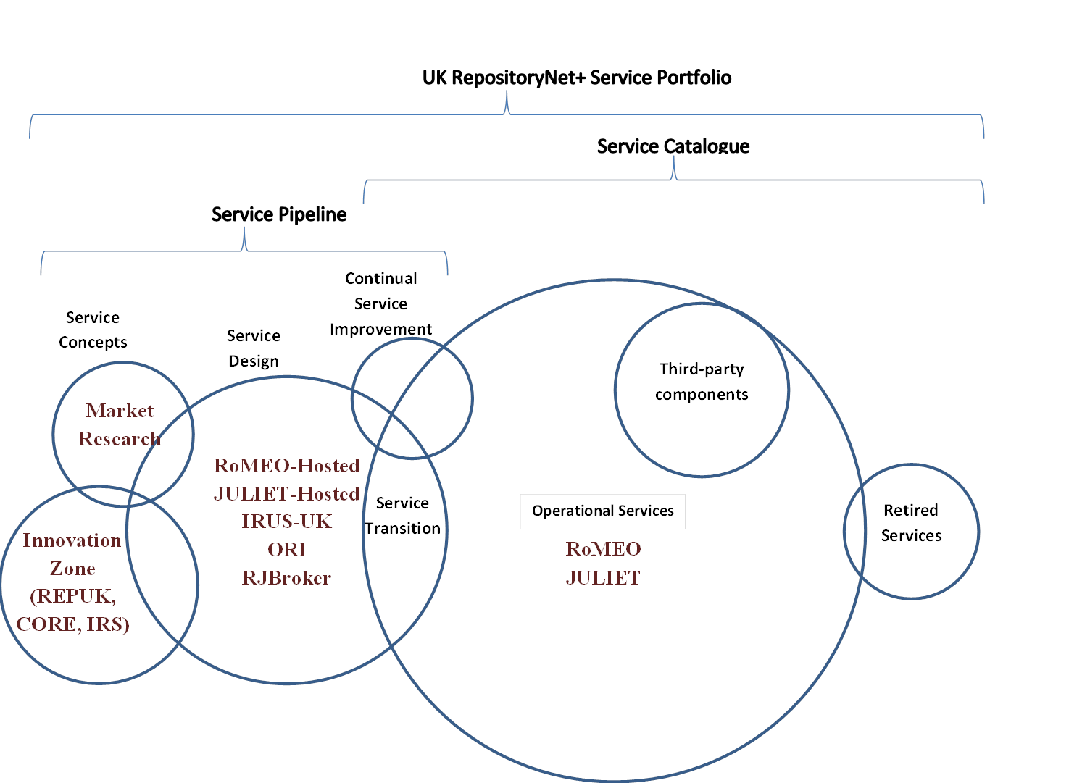

2. How the proposal addresses the conference themes
This paper will address the following OR2013 themes:
- Effective re-use of software, services, and infrastructure to support repository development
- Services making use of repository metada
In designing a data-driven infrastucture for the RepNet services, RepNet have developed a robust set of APIs giving third-party developers access to the underlying data, enabling this to be resurfaced and re-used in other RepNet services or through potential new applications to be built on existing components. The RepNet services also make extensive use of repository metadata through aggregation to create a development platform for new services such as improved discovery of research articles through exposure to indexing search engine spiders and enhanced reporting to support OA mandate compliance.

http://tinyurl.com/cpocj65

