The Heterogenous Zone: Five use cases for five research data collections in Edinburgh DataShare
Robin Rice, University of Edinburgh
This presentation will focus on five different research communities, their data collections, and the unique user requirements for the research data they submitted to the University of Edinburgh data repository, Edinburgh DataShare. It will tell the story of how well repository staff were able to respond to their requirements based on known functionality in DSpace and the ability to plan for further development.
The author has presented at a previous DSpace User Group meeting, in 2009 in Gothenburg, on “Edinburgh DataShare: Tackling Research Data in a DSpace Institutional Repository”. Since that time there has been much more interest in archiving research data in IRs. The local context for the service has also changed. In 2011, the University of Edinburgh passed a Research Data Management Policy (the first by a UK university). In 2012, it published a Research Data Management (RDM) Roadmap, by which it showed its commitment to implementing the policy. Through a range of coordinated activities aimed both at raising the awareness of researchers across the University about their commitments to manage research data well, and at shoring up the relevant IT service infrastructure, the Roadmap aims to ease the path towards policy realisation.
Figure 1: An abstraction of the University of Edinburgh RDM Roadmap.
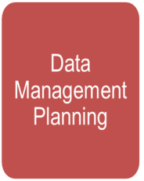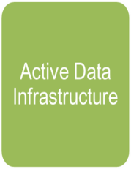
Edinburgh DataShare is seen by the RDM Steering Group as one of the key RDM services offered by Information Services, and as such has challenged its staff to meet the requirements of a number of pilot submissions from a range of different types of research communities with special kinds of data.

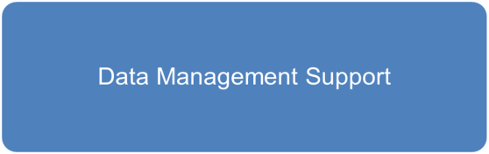
Through this presentation, the gist of each pilot’s requirements will be explained, followed by the response from the repository staff. Responses ranged from simply improving the user experience of the deposit process, to adding special view and display functions, to considering new forms of restricted access to datasets, to streamlining batch ingest processes and facilitating new ways to query the contents of a particularly large data collection. In some cases the work will have been completed, in others it is a work in progress, where audience input towards better solutions is welcome.

http://datashare.is.ed.ac.uk/
http://www.slideshare.net/rcrice/edinburgh-datashare-tackling-research-data-in-a-dspace-institutional-repository
http://www.ed.ac.uk/is/research-data-policy
http://www.ed.ac.uk/schools-departments/information-services/about/strategy-planning/rdm-roadmap

