The sharing and re-use of research data and outputs via the application of RADAR, The Glasgow School of Art’s research repository

Dr Robin Burgess. The Glasgow School of Art, 167 Renfrew Street, Glasgow, G3 6RQ, United Kingdom. (r.burgess@gsa.ac.uk)

For the past two years the Glasgow School of Art (GSA) have been heavily involved in improving the management of their research outputs. They have been supported through funding from JISC that enabled them to develop an improved research repository, moving away from a standard Filemaker Database to an EPrints enabled repository system. Much of the initial development of the repository focused on the ability to embed the system within the research ethos at GSA. This has been enhanced and aided by web based technology and help from ScreenMedia a web design company (Fig 1). More recently however, the focus has shifted towards the management of the data within the repository in relation to its use on an internal and external scale, so not just for the institution, but for interested parties.

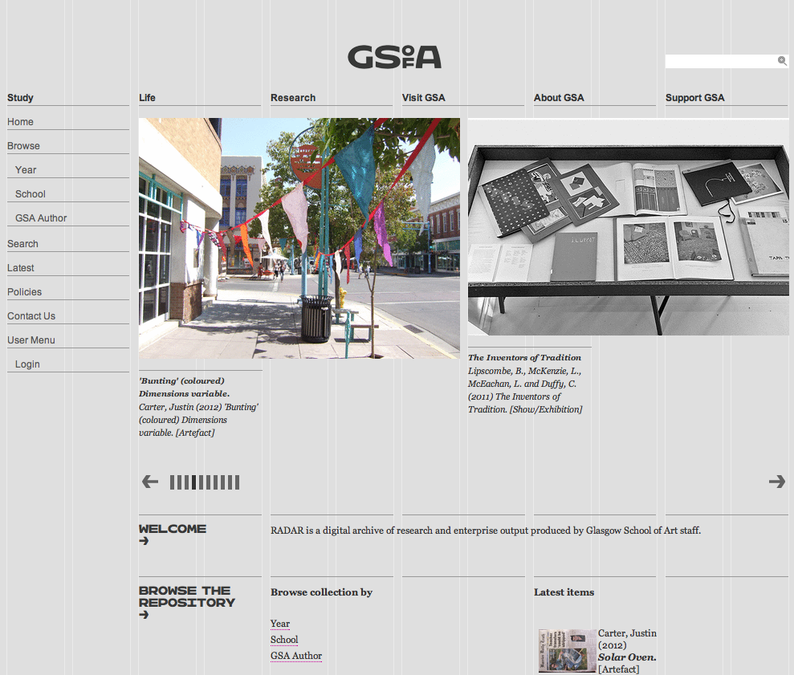
Fig 1: RADAR the research repository at GSA (www.radar.gsa.ac.uk)

This paper aims to illustrate the work that GSA have been doing via the use of RADAR (our embedded repository) to help ensure effective use and re-use of content and research data in the visual arts.

Visual arts research data can be seen as complex and complicated, therefore appropriate methods and systems for managing this data are required. Research repositories are integral to this process. RADAR has been implemented at GSA and research staff are using the repository to upload details related to their research outputs. Textual information alongside evidence of research outputs are present and integrated into the repository using standard EPrints capabilities that have been ‘kulturised’ (http://kultur.eprints.org/) to enhance the uploading of arts related data.

RADAR like most repositories is an open source system that enables individuals to access details related to the research that is being undertaken at GSA. This functionality allows for sharing and re-use of information.

It can be stated that there are two main functions of RADAR that is helping the management of research data for re-use.

- RADAR as a data management system, integrated with the GSA website
- EPrints REF module, for helping to enhance GSAs submission to the Research Excellence Framework Assessment

By working with EPrints the information from filemaker was extrapolated into the standard Eprints repository platform. Then with the help of ScreenMedia (a local web design and creative company) GSA were able to modify the EPrints repository so that it is in line with the new GSA website (Fig 2). This has aided the embedding and integration of the system within the institute, while the work carried out by EPrints has drastically improved the usability of the repository.

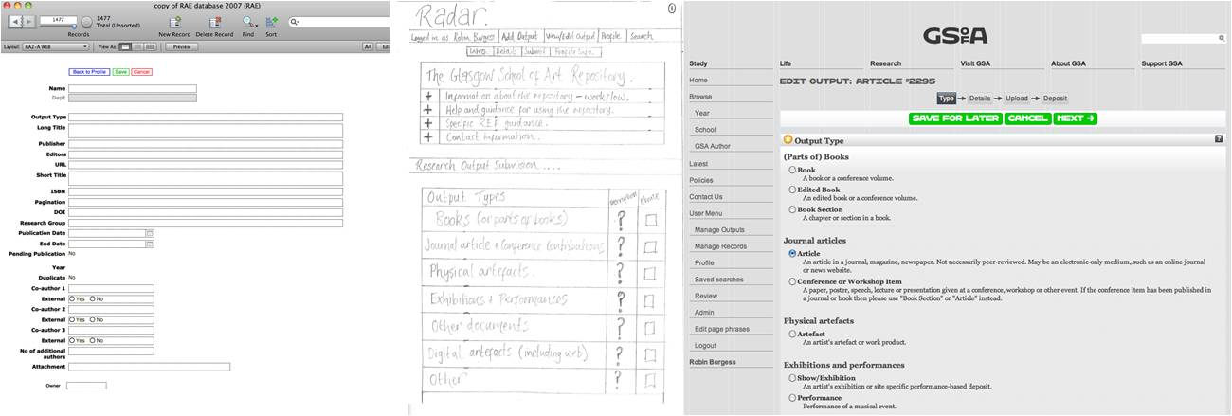
Figure 2: The stages of development for RADAR. Image 1 shows the filemaker database. Image 2 illustrates sketches and designs for the new repository. Image 3 is one page from the new repository, embedded within the new GSA website.

The Research Excellence Framework (REF) is the new system for assessing the quality of research in UK higher education institutions (HEIs) and will be completed in 2014.
The REF will be undertaken by the four UK higher education funding bodies. The exercise will be managed by the REF team based at HEFCE and overseen by the REF Steering Group, consisting of representatives of the four funding bodies.
The primary purpose of the REF is to produce assessment outcomes for each submission made by institutions:
- The funding bodies intend to use the assessment outcomes to inform the selective allocation of their research funding to HEIs, with effect from 2015-16.
- The assessment provides accountability for public investment in research and produces evidence of the benefits of this investment.
- The assessment outcomes provide benchmarking information and establish reputational yardsticks.

RADAR is the data management system at GSA that is being used for storing and managing the information related to the research being undertaken, the research that will be assessed by the REF process. To help this process, EPrints the developers of the repository have set up a REF Module that can link through to the submissions system for REF that HEFCE have set up. GSA are involved in using this module to help automate their submission to REF.

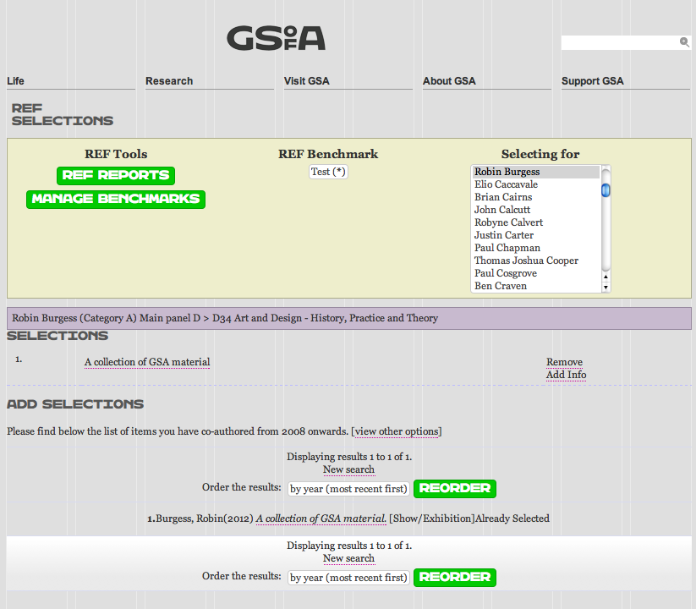
Fig 3: Screenshot of the REF module in RADAR

The REF module allows repository managers to:

- Assign staff to Units of Assessment and manage REF1 (staff related) data
- Assign Unit of Assessment champions
- Select outputs
- Rate and qualify selections
- View REF1 (staff and circumstances) and REF2 (outputs) reports
- Run multiple benchmarks
- Export reports in multiple formats

By applying the EPrints REF Module within RADAR, GSA have been able to focus the management of their outputs on those required for REF and to help ensure the quality of submissions made to RADAR are inline with the requirements for REF. This has helped staff/researchers to be more attentive towards the quality and content of the information they upload with their outputs, as it is to be seen by other people for the assessment process.

This increased awareness of the need to submit high quality research outputs to the repository for the purposes of REF helps to enhance the research output content in the repository in general, for the benefit of GSA, in relation to showcasing the nature of research being undertaken at the School.

It can be stated that RADAR is being used to manage the research outputs being produced at GSA. Staff are encouraged to upload details of their work and research to the repository to help promote the school but themselves as well. In addition to the basic metadata about the output submitted to RADAR, staff have the ability to upload documents associated with the research – e.g. text files, images, video, data etc. This ability to share documents alongside the basic details about the outputs enhances re-use and knowledge exchange. As RADAR is public facing and linked to the GSA website, external bodies can access the information from the repository, interrogate its content and subsequently learn about the work being undertaken at GSA. This in turn may instigate further communication with the school about specific areas of work, and lead to collaborative work and further knowledge exchange. The open nature of RADAR and the ability to share details and documents about research in the repository really helps to spread the word about the work being undertaken at GSA, and lead to potential re-use of data amongst the visual arts community.

In addition to the use of the actual repository (RADAR) for the management of research data for re-use purposes, GSA have also been involved in another JISC funded project, working alongside the Visual Arts Data Service (VADS), called KAPTUR (http://www.vads.ac.uk/kaptur/). This project has been focused on the development of Research Data Management Policies and infrastructure for the management of research data. Part of the policy and infrastructure development has involved consideration towards the handling, management, and re-use of research data and its content. This consideration is something that has needed to be included in the research data management policy that has been developed at GSA.

Research data is seen as a valuable resource and, with appropriate curation and management, it has much to offer learning, teaching, research, knowledge transfer and consultancy activities in the visual arts. The application of suitable management systems such as research repositories (RADAR) and the application of suitable policies and procedures will help to enhance this resource and the ability to share information in a clear and effective way, both within an institute but also to external bodies.

